**SALARY SURVEY 2021 -USING ADVANCED EXCEL & SQL**

**DATA OVERVIEW:**

The data set consist of attributes like Age range, Industry, Job Title, Clarification of job title, Annual salary, Additional Monetary Compensation, Currency, Other currency, Income clarification, Country, State, City, Professional Experience, Level of education & Gender.

**OBJECTIVE:**

The objective is to analyse the sales trends across various parameters and provide actionable business insights using Advanced Excel & SQL. To identify high performing industry and low performing industry.

**DATA CLEANING & PRE-PROCESSING:**

The raw data was cleaned by handling missing values, standardizing data types, handling inconsistent values.

HANDLING MISSING VALUES:

For numerical values the missing values were filled with mean value, whereas in the categorical column the missing values were filled with unknown

STANDARDIZING DATA TYPES:

Ensured all columns have appropriate data types

HANDLING INCONSISTENT VALUES:

Variation in spelling got checked. Different formats of the country got clubbed into one and ensured consistent capitalization for categorical columns.

By following the above method cleaned the data. The cleaned data contains 27928 rows.

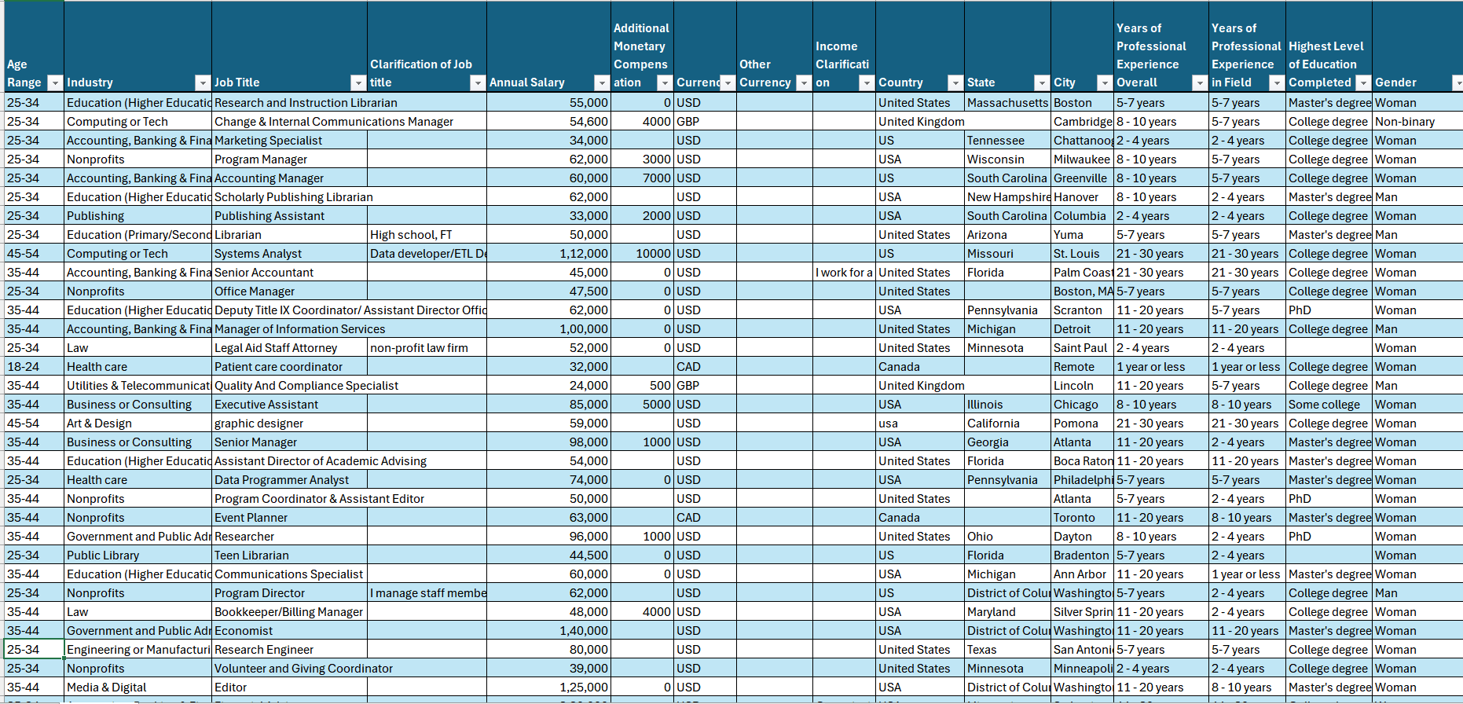

Raw data

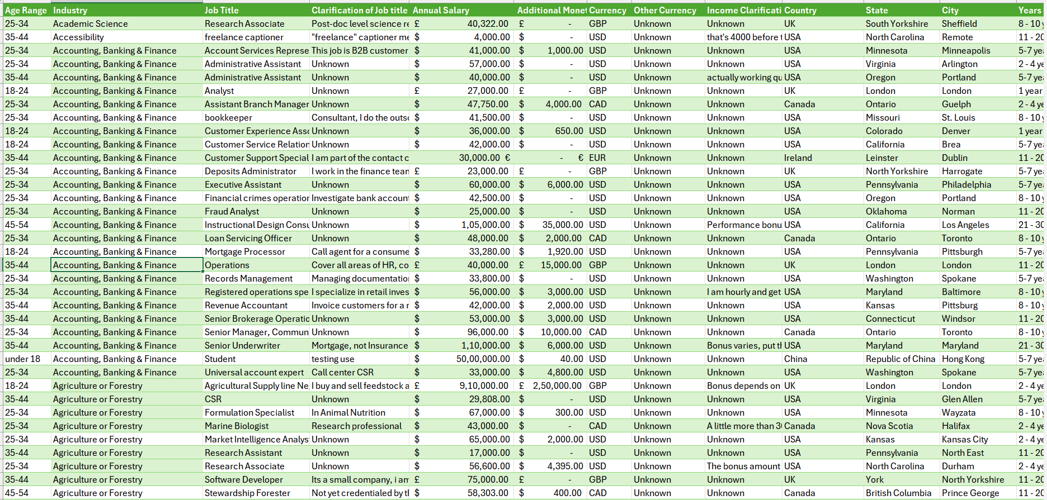

Cleaned data

**INCORPORATED CLEANED DATASET IN MYSQL:**

I created a database and created a table with appropriate titles in cleaned dataset.

Since the cleaned data is bulk I have incorporated that using an SQL code mentioned below.

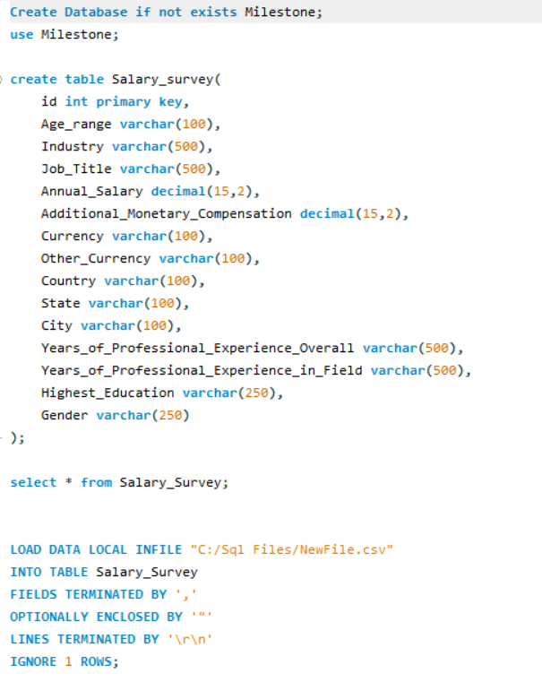

**QUERYING**

I have queried the data required for dashboard creation using MY SQL.

* 1. Average Salary by Industry and Gender

I compared the average salary within each industry, split by gender. This helps identify potential salary discrepancies based on gender within industries.

* 1. Total Salary Compensation by Job Title

I found the Total monetary compensation (base salary + additional monetary compensation) for each job title. This would show which roles have the highest overall compensation.

* 1. Salary Distribution by Education Level

I found the salary distribution (average salary, minimum, and maximum) for different education levels. This would help analyze the correlation between education and salary.

* 1. Number of Employees by Industry and Years of Experience

I determined how many employees are in each industry, broken down by years of professional experience. This could show if certain industries employ more experienced professionals.

* 1. Median Salary by Age Range and Gender

I calculated the median salary within different age ranges and genders. This could provide insights into salary trends across different age groups and gender.

* 1. Job Titles with the Highest Salary in Each Country

I found the highest-paying job titles in each country. This helped me understand salary trends across different countries and highlight high-paying positions.

* 1. Average Salary by City and Industry

I Calculated the average salary for each combination of city and industry. This shows which cities offer higher salaries within each industry.

* 1. Percentage of Employees with Additional Monetary Compensation by Gender

I Found the percentage of employees within each gender who receive additional monetary compensation, such as bonuses or stock options.

* 1. Total Compensation by Job Title and Years of Experience

I determined the total compensation (salary + additional compensation) for each job title based on years of professional experience. This helped me highlight compensation trends based on experience levels within specific job titles.

* 1. Average Salary by Industry, Gender, and Education Level

I Understood how the salary varies by industry, gender, and education level. This query could provide a comprehensive view of how multiple factors influence salary.

Exported each query from My SQL and imported as CSV file in the Excel as separate sheet.

DATA MODELLING:

Connected the queried result sheets through Data modelling

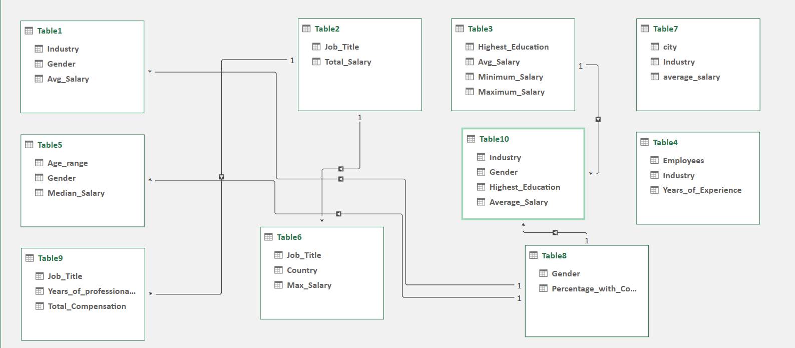

**PIVOT TABLE AND DASHBOARD CREATION:**

* Created Pivot Tables and charts.
* Added Slicers.
* Implemented KPI’s

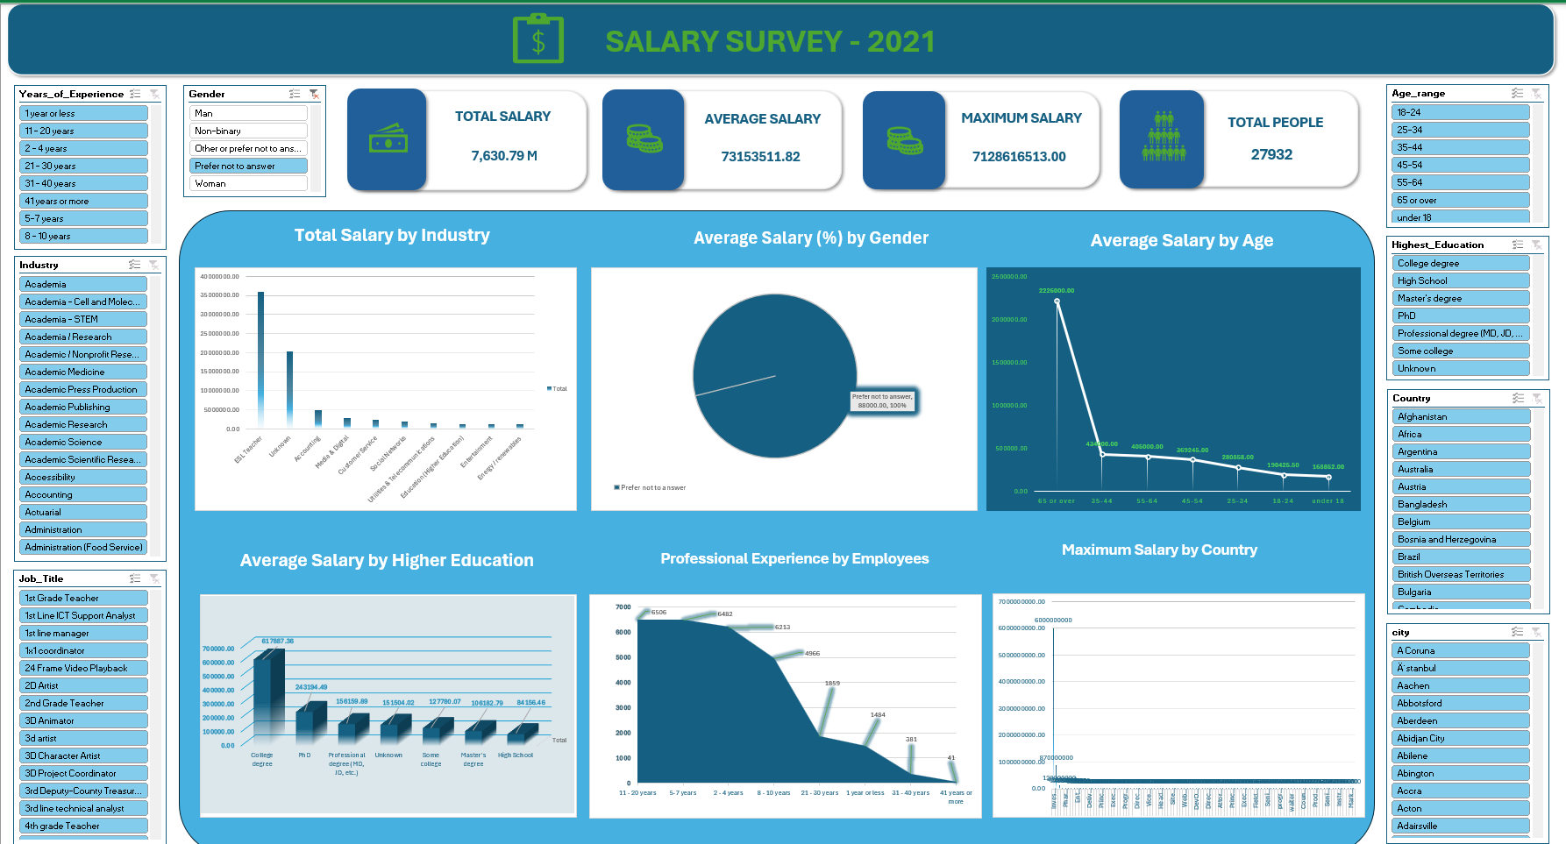

**INSIGHTS & RECOMMENDATION:**

* Regional operations Manager, Researcher role has more total compensation.
* PHD-Qualifications have more salary followed by college degree and Professional degree.
* Computing Technology, Education, Health care have a greater number of employees.
* In salary trends across gender: nonbinary has more salary followed by men and then women.
* Highest salary is offered by the country Indonesia and Columbia.
* Even the top-end salary is unimpressive in Lotreland, Myanmar, Bosnia, Cuba.
* City with highest earning potential is Bogotá & Bandung.
* High paying industry are Education, Media & Digital, Utilities& Telecommunication, Accounting & Tech.
* Gender pays gap is around 4% in the given salary dataset

**RECOMMENDATION:**

* **Gender pay gap** - It could be managed by providing equal opportunity. Analyze salaries by gender to identify disparities & ensure equal pay for employees with similar experience, skills, and responsibilities.
* **Skill incorporation**- Despite masters degree , college degree holds more salary . Inculcating skills and hands on experience in the required field is more essential to yield more results
* **Migration rate** – If good skills are not appreciated, brain drain could happen. Inorder to avoid migration total compensation, bonus could be given to increase the retention rate.